OLEDB Connectivity (Telephone Directory DataBase)
Ex.No: 9
Date: 23-02-2015
AIM
To establish OLEDB connection and manipulate the Telephone Directory database.
PROCEDURE
- The OLEDB connection is established in visual studio using visual basic.
- In the data source tab, select new datasource then select database and then dataset.
- Then the required database is selected and the necessary table is included in the project.
- Drag the table into the design view and then the manipulation is performed.
Code:
TelephoneDirectory _Details.vb

package JavaApplication1;

import java.sql.*;
import java.util.*;
public class Main {

public static void main(String[] args) throws SQLException {
// TODO code application logic here
Connection con = null;
Scanner in = new Scanner(System.in);

try

{

Class.forName("oracle.jdbc.OracleDriver");
con=DriverManager.getConnection("jdbc:oracle:thin:@192.168.0.1:1521:oracle1", "ruser1", "ruser1");
Statement st = con.createStatement();

int n = 0;
while (n != 4)
{
System.out.println("\n\n\t\t DATABASE-\n\nEnter 1 to Display\nEnter 2 to Delete\nEnter 3 to Insert\nEnter 4 to Exit\nUser Input: ");
n = Integer.parseInt(in.next());
switch(n)
{
case 1:
ResultSet rs1 = st.executeQuery("select * from cust");
while (rs1.next())
{ System.out.println(rs1.getString(2)); }
break;
case 2:
st.executeUpdate("delete from cust where Name = 'arun'");
break;
case 3:
st.executeUpdate("insert into cust (cust_id,name,address) values(3345,'logesh','chennai')");
break;
case 4:

break;

default:
break;
}
}

}
catch(Exception e)
{System.out.println(e);}
finally {
con.close();
}
}

}

Output

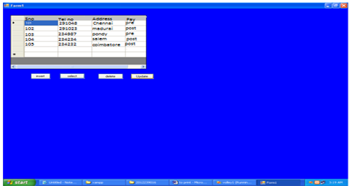

Result:
Thus OLEDB connection is established and the Telephone Directory database is manipulated.

JDBC Connectivity (Telephone Directory DataBase)
Ex.No:10
Date: 23-02-2015
AIM
To establish JDBC connection and manipulate the Telephone Directory database.
PROCEDURE
- The JDBC connection is established using java in NetBeans.
- In order to establish the connection, ojdbc driver should be included in the project.
- Then in the corresponding connection the appropriate username password and host string are provided.
- The necessary packages are included in the program.
Code
Main.java

package petstore;

import java.sql.*;
import java.util.*;
public class Main {

public static void main(String[] args) throws SQLException {
// TODO code application logic here
Connection con = null;
Scanner in = new Scanner(System.in);

try
{

Class.forName("oracle.jdbc.OracleDriver");
con = DriverManager.getConnection("jdbc:oracle:thin:@192.168.0.1:1521:oracle1", "ruser43", "ruser43");
Statement st = con.createStatement();

int n = 0;
while (n != 4)
{
System.out.println("\n\n\t\tPETSTORE DATABASE-\n\nEnter 1 to Display\nEnter 2 to Delete\nEnter 3 to Insert\nEnter 4 to Exit\nUser Input: ");
n = Integer.parseInt(in.next());
switch(n)
{
case 1:
ResultSet rs1 = st.executeQuery("select * from PETSTORE");
while (rs1.next())
{ System.out.println(rs1.getString(2)); }
break;
case 2:
st.executeUpdate("delete from PETSTORE where Name = 'Test'");
break;
case 3:
st.executeUpdate("insert into PETSTORE (id, name, color, type, cost) values('g7342', 'Yellow Canopy', 'Gold', 'Frog', '$30.00')");
break;
case 4:

break;

default:
break;
}
}

}
catch(Exception e)
{System.out.println(e);}
finally {
con.close();
}
}

}

Output

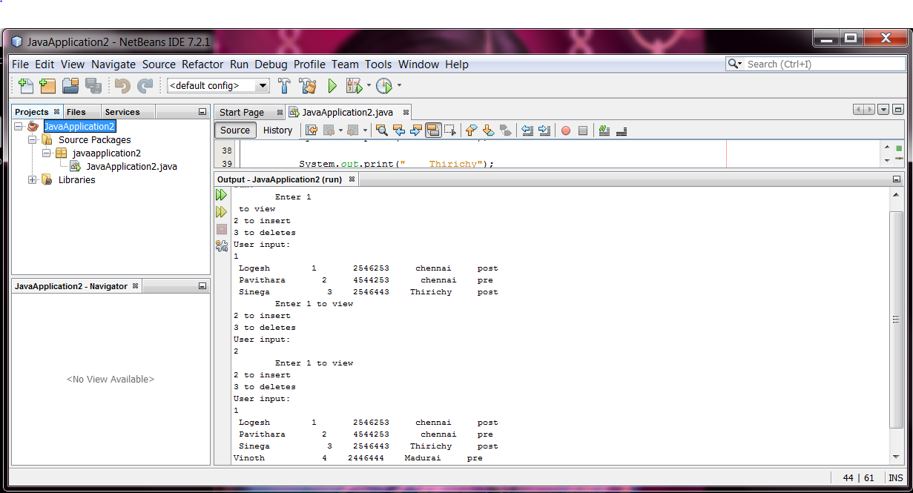

Result:
Thus JDBC connection is established and the Telephone Directory database is manipulated.

